* 1. General Information
     1. Design Code : **IS456:2000**
     2. Unit System : N, mm
  2. Material
     1. : 25.00MPa
     2. : 415MPa
  3. Design Load
     1. Dead Load : 3.000kN/m²
     2. Live Load : 3.000kN/m²
  4. Section Size
     1. Span : 4.000m
     2. Thickness : 199mm
     3. Cover : 20.00mm

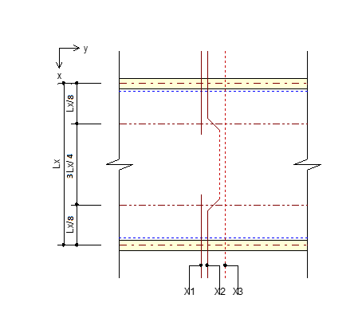

* 1. Slab Type & Support
     1. Slab Type : 1-Way Slab
     2. Support Type : Case-1
  2. Check Load
     1. Calculate factored load **[IS456:2000 Table 18]** 
        + LCB = 8.400kN/m² ( 1.5D+1.5L )
        + 8.400kN/m²
  3. Check Thickness of Slab
     1. Calculate minimum thickness required **[IS456:2000 24.1]**
        + 200mm
  4. Check Capacity of Slab
     1. Calculate Moment & Shear

|  |  |  |  |
| --- | --- | --- | --- |
| **Check Items** | **TOP** | **MIDDLE** | **BOTTOM** |
| Bar-1 | P3@500 | - | P3@500 |
| Bar-2 | P3@500 | P3@300 | P3@500 |
| Bar-3 | P3@500 | P3@400 | P3@500 |
|  | 5.600 | 16.80 | 5.600 |
|  | 16.80 | 0.000 | 16.80 |
|  | 17.52 | 25.36 | 17.52 |
|  | 109 | 109 | 109 |
|  | OK(0.320) | OK(0.662) | OK(0.320) |
|  | OK(0.154) | OK(0.000) | OK(0.154) |
|  | 315 | 315 | 315 |
|  | OK(0.794) | OK(0.556) | OK(0.794) |

* 1. Check Deflection
     1. Criteria for deflection
        + Total Deflection : Span/250 **[IS:4562000 23.2 b]**
     2. Time-dependent factor **[IS:4562000 6.2.5.1]**
        + Duration for sustained load : 27 days
        + Creep coefficient = 1.600
     3. Calculate crack moment of section
        + **[IS:4562000 6.2.2]**
        + **[IS:4562000 C-2.1]**
     4. Calculate positive moment
     5. Calculate inertia of moment for positive section **[IS:4562000 C-2.1 ]**
        + **[IS:4562000 C-2.1 ]**
     6. Calculate effective inertia of moment
     7. Calculate deflection
        + K = 1.000
     8. Calculate Creep deflection **[IS:4562000 C-3.1]**
        + = 0.1
        + = 325
        + = 0.0003
     9. Calculate Shrinkage deflection **[IS:4562000 C-4.1]**
        + Ece = = 15000
        + Δi+cp = = 0.0006
        + Δcp = Δi+cp – Δi=D = 0.00056
     10. Calculate Total Deflection

Total deflection = 0.0400mm ( Span/25,027 < Span/250 → O.K )